AUE Annual Conference 2025 – EXCURSIONS
EXCURSION 1
To: Thorn Lighting’s State-of-the-art Manufacturing Facility Tour.
Summary: The visit gave participants the opportunity to see and experience the latest in innovative lighting solutions and technologies with a fully comprehensive guided tour of Thorn’s Lighting’s state-of-the-art manufacturing facility included.
Participants could learn about Thorn’s incredible sustainable production methods and get an insight into their cutting-edge photometric laboratory.

EXCURSION 2
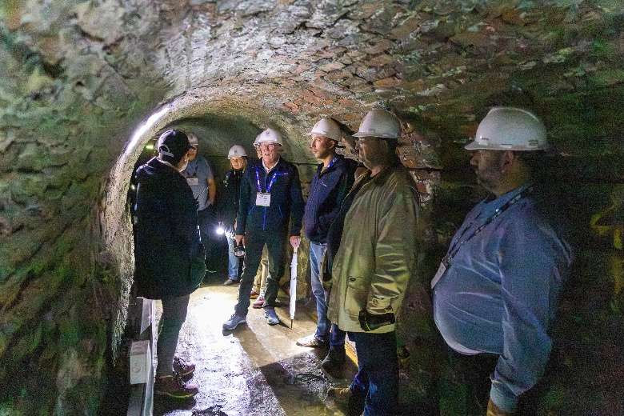
Title: Ouseburn Trust - Victorian Tunnel Tour.
Summary: The excursion consisted of a guided tour through the historic Victoria Tunnel, led by Ouseburn Trust. Experience Newcastle’s hidden underground wagonway, the tunnel was originally built in the 19th century to transport coal and later used as a WWII air-raid shelter.

EXCURSION 3
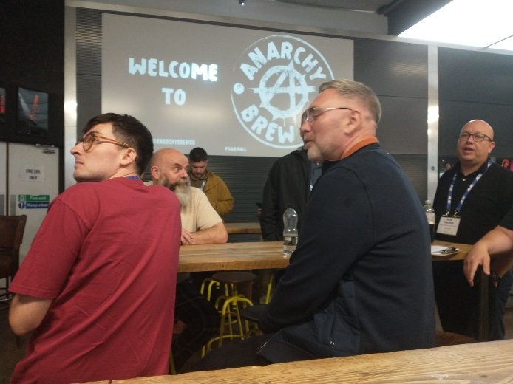
Title: Anarchy Brew Co Tour.
Summary: Participants could explore the brewery, learn about the brewing process and the craftsmanship behind Anarchy Brew & Co unique beers. This tour included insights into the brewing techniques, ingredients, and the history of Anarchy Brew & Co. The tour included a tasting session, where guests could sample a range of signature brews.

EXCURSION 4
Title: Discovery Museum Tour.
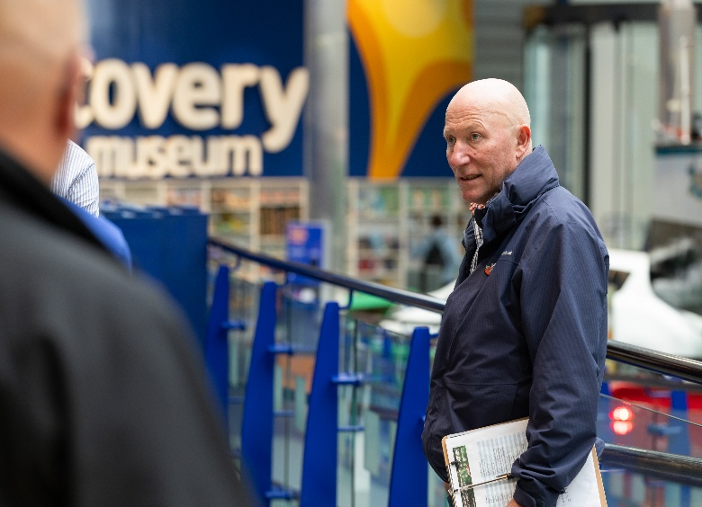
Summary: The tour offered a fascinating journey through Newcastle’s history and innovation. During the guided tour, participants could explore key exhibits, from the region's maritime heritage and industrial past to ground breaking scientific discoveries. The tour highlighted the city’s role in shaping global industries and introduces visitors to the influential people and inventions that made it all possible.

