AUE Annual Conference 2025 – PLENARY SESSIONS
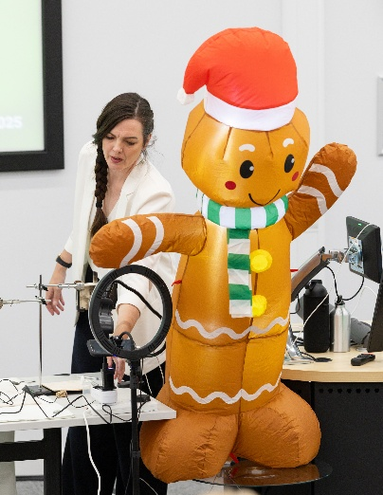
SESSION 1
Title: Betamax: How to be Wrong When You Are Right.
Speaker: Fran Scott, Scientist, Engineering Broadcaster and Pyrotechnician.
Summary: Is the most logical solution the one that always wins? If only it was that simple. Fran through her signature destructive, home-spun demonstrations, guided us through the illogical world of being right.

SESSION 2
Title: District Energy - Full Circle on the Path to Net Zero.
Speaker: Matt Dunlop, Senior Sustainability Manager (Net Zero), Newcastle University.
Summary: Newcastle University's approach to District Energy, and its place within the University's Net Zero Strategy. The session covered a case study on Merz Court Biofuel CHP, with an optional tour included. The session explained how the project was conceived, funded and delivered, and the University's next steps towards the decarbonisation of heat on campus.

SESSION 3
Title: Unlock the value of Building Information Management (BIM) over the whole asset lifecycle (Not just for 3D BIM Construction Projects).
Speaker: Andrew Green (FRICS, ACIBSE, MIAM), Solution Architect, Director, AtkinsRéalis.
Summary: The session brought to life ‘BIM' from the university engineer’s perspective! - from the start of any major projects and in use during the operational life cycle. Explaining how utilising ‘Better Information Management’ (BIM) can unlock real value in the ‘day-to-day' working life of Engineers and for the students and other stakeholders.

SESSION 4
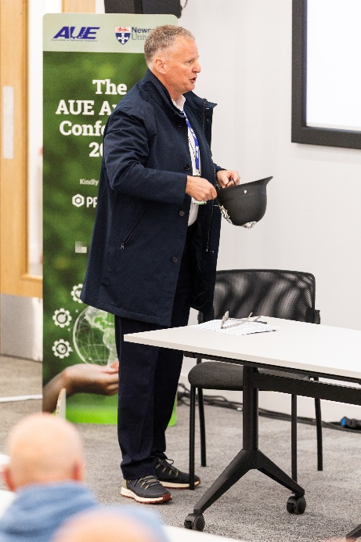
Title: An Inspector Calls - What to do and what not to do.
Speaker: Ray Scanlan BEng(Hons) CEng MIET, RBS Electrical Engineering Ltd.
Summary: The consequences of failing to comply with the law and special regulations could lead to the death or serious injury of a person(s) and the prosecution of duty holders, organisations and other participants. The session shared the information to prepare engineers and managers for the future and avoid the knock on the door from the HSE Inspector with the aim to cover:
• When would an HSE Inspector call?
• A real-life “HSE Inspector’s Interview”

