2026 AUE Annual Conference Main Sponsors: Thorn and Zumtobel Lighting
Whether you're delivering campus refurbishments, creating flexible learning environments, improving student wellbeing or progressing your university's sustainability and net zero ambitions, visit the Thorn and Zumtobel team to discover innovative, intelligent, energy-efficient lighting and smart controls solutions designed specifically for higher education.
Lighting Solutions for Smarter, More Sustainable Campuses
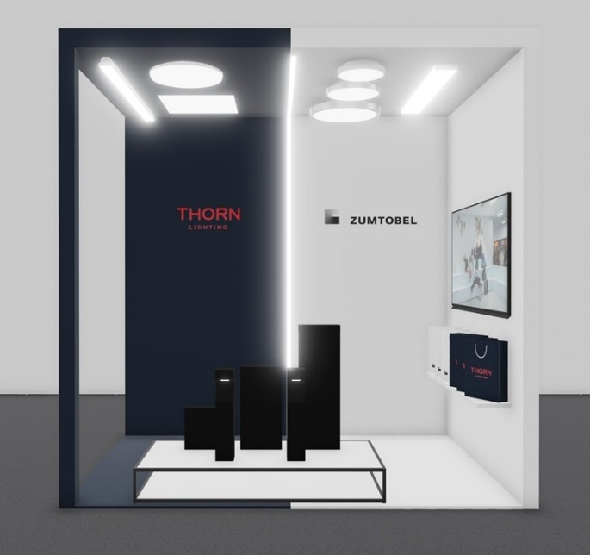

Thorn College 2
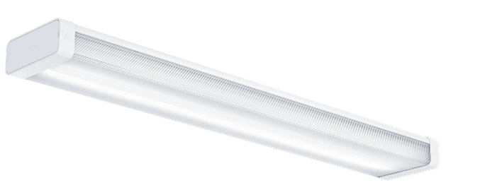
Designed for lecture theatres, classrooms and teaching spaces, College 2 delivers exceptional visual comfort, low-glare, diffused light and excellent colour rendering, simplified installation and easy maintenance.
https://www.thornlighting.co.uk/en-gb/f/7934870
Watch the video: https://www.youtube.com/watch?v=SqIzV_gapOk&list=PLnSroxjLc_nQluJ7TPeak_y80Kuk6LQkd
Zumtobel TECTON II
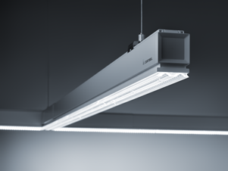

Experience the latest generation of the renowned continuous-row lighting system. Ideal for large circulation areas, libraries and multi-purpose university buildings, TECTON II combines outstanding lighting quality, sustainability, flexibility and intelligent connectivity.
https://www.zumtobel.co.uk/en-gb/f/7933135
https://www.youtube.com/watch?v=gqyrSV3PAUk
Lighting Solutions for Every Area of the University Campus
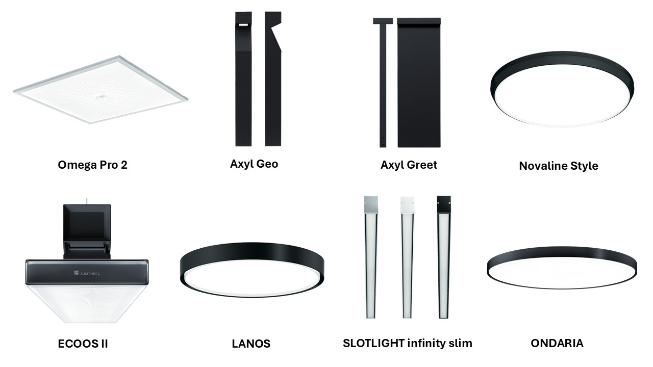

Explore a complete portfolio of lighting solutions for every area of the university campus, including classrooms, offices, collaborative spaces, libraries, outdoor pathways and social spaces, featuring Thorn’s Omega Pro 2, Novaline Style, Axel Greet and Axyl Geo outdoor range and Zumtobel’s ECOOS II, LANOS, SLOTLIGHT infinity slim and ONDARIA.
Meet the Lighting Specialists and Receive an Exclusive Gift Box
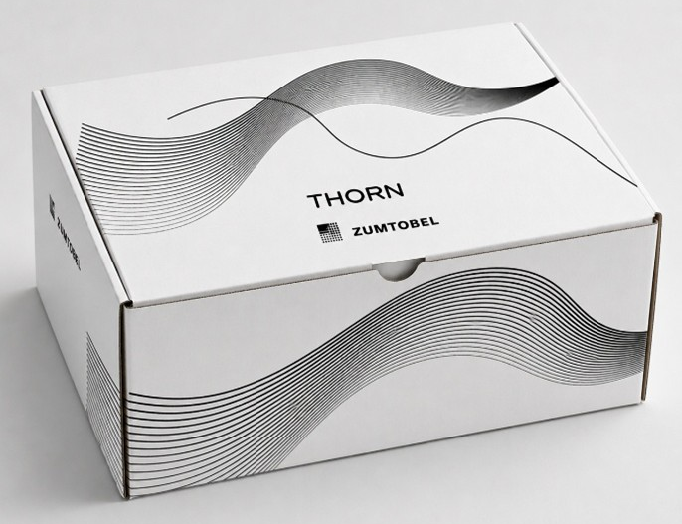

Meet the Thorn and Zumtobel lighting specialists, explore the latest innovations, and discover how intelligent, sustainable lighting can help your university reduce energy consumption, support decarbonisation targets and create safer, more engaging learning environments for students and staff.
As a thank you for visiting, you will receive an exclusive Thorn and Zumtobel gift box.
Don’t miss out! The Thorn and Zumtobel Team look forward to welcoming you to their stand.

